

Foundations of Programming
Assignment No. : 11

PROBLEM STATEMENT:
Write a program in C to accept a number from the user and compute the following:
- Square root of the number
- Square of the number
- Cube of the number
- Check whether the number is prime
- Factorial of the number
- Prime factors of the number

OBJECTIVE:
• To understand the use of mathematical operations in C.
• To implement loops and conditional statements
. • To perform number-based computations.
• To enhance logical thinking using menu-driven programs.

THEORY:
Numbers and their mathematical properties play a vital role in programming. Operations such as square, cube, and square root are basic mathematical computations. Prime number checking involves verifying whether a number has exactly two divisors. Factorial is calculated by multiplying a sequence of integers. Prime factorization breaks a number into its prime components. In C programming, these operations can be efficiently implemented using loops, conditional statements, and mathematical functions.

PLATFORM:
Linux

ALGORITHM:
- Start
- Declare variables num, choice, i, fact, and flag
- Accept an integer number num from the user
- Display a menu of operations:
- Square Root
- Square
- Cube
- Check Prime
- Factorial
- Prime Factors
- Accept the user’s choice
- Use a switch–case statement based on the selected choice
- If choice is:
- Square Root:
  - Check if number is negative
  - If not negative, calculate square root using sqrt()
- Square:
  - Calculate num × num
- Cube:
  - Calculate num × num × num
- Check Prime:
  - Check divisibility from 2 to num / 2
  - If divisible, number is not prime
- Factorial:
  - If number is non-negative, calculate factorial using loop
- Prime Factors:
  - Divide the number by all possible prime numbers starting from 2
- Display the result of the selected operation
- Stop

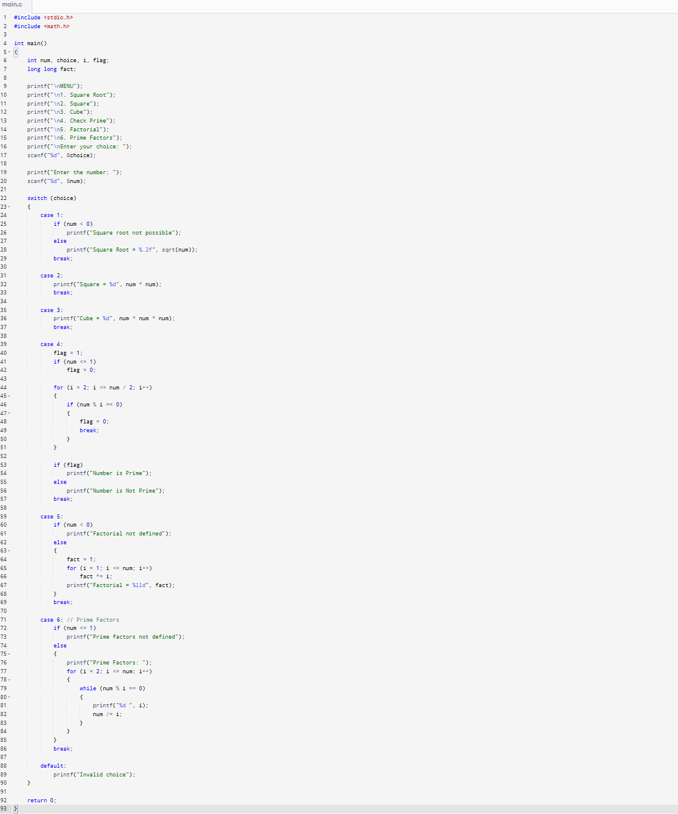
C PROGRAM:

INPUT/OUTPUT:
The user enters an integer number and selects an operation from the menu.
Example Input: Number: 5 Choice: 3

Example Output:
The program displays the result based on the selected operation.
Example Output: Cube = 125

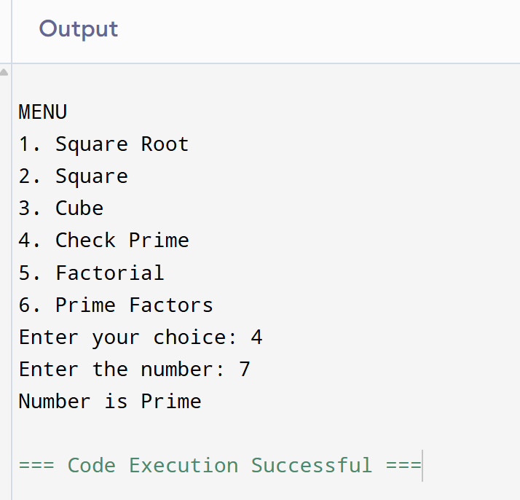

CONCLUSION:
Thus, the program to perform various mathematical operations on a number was successfully implemented using C programming. This program demonstrates the use of loops, conditional statements, switch-case, and mathematical functions.

